**GOVERNMENT ARTS COLLEGE,OOTY**

**DEPARTMENT OF PHYSICS**

**ESTIMATION OF BUSINESS EXPENSES**



**MENTOR:Dr.J.MANIKANDAN**

**Sumitted By**

**TEAM LEADER:PRIYADHARSHINI.A (2122C0203)**

**TEAM MEMBER 1:RAMYA.S (2122C0204)**

**TEAM MEMBER 2:SHALINI.S (2122C0205)**

**TEAM MEMBER 3:ASHOK.G (2122C0206)**

**GOVERNMENT ARTS COLLEGE,OOTY**

**UDHAGAMANDALAM**

**DEPARTMENT OF PHYSICS**

**MENTOR:Dr.J.MANIKANDAN**

**TEAM LEADER:PRIYADHARSHINI.S**

**TEAM MEMBER 1:RAMYA.S**

**TEAM MEMBER 2:SHALINI.S**

**TEAM MEMBER 3:ASHOK.G**

**ESTIMATION OF BUSINESS**

**EXPENSES**

1. **INTRODUCTION**
   1. **OVERVIEW**

An expense is the cost of operations that a company incurs to generate revenue. It is simply defined as the cost one is required to spend on obtaining something. As the popular saying goes, “it costs money to make money.”Common expenses include payments to suppliers, employee wages, factory leases, and equipment [depreciation](https://www.investopedia.com/terms/d/depreciation.asp). Businesses are allowed to write off tax-deductible expenses on their income tax returns to lower their [taxable income](https://www.investopedia.com/terms/t/taxableincome.asp) and thus their tax liability; however, the [Internal Revenue Service](https://www.investopedia.com/terms/i/irs.asp) (IRS) has strict rules on which expenses businesses are allowed to claim as a deduction.

One of the main goals of company management teams is to maximize profits. This is achieved by boosting revenues while keeping expenses in check. Slashing costs can help companies to make even more money from sale. However, if expenses are cut too much it could also have a detrimental effect. For example, paying less on advertising reduces costs but also lowers the company’s visibility and ability to reach out to potential customers.

* 1. PURPOSE.

An estimate is a document that [provides potential customers with an approximation of the cost of goods or services](https://oboloo.com/glossary/4pl-service-providers/" \t "https://oboloo.com/blog/what-is-an-estimate-in-business-definition/_blank). An estimate can be used to provide an approximate price for a project, product, or service. Estimates are often used in the [construction industry](https://oboloo.com/glossary/bookkeeping-construction-industry/" \t "https://oboloo.com/blog/what-is-an-estimate-in-business-definition/_blank), but can be found in other industries as well.

Estimates are important because they allow businesses to [set expectations](https://oboloo.com/blog/how-can-a-budget-be-used-to-set-expectations-and-manage-contractual-obligations-2/" \t "https://oboloo.com/blog/what-is-an-estimate-in-business-definition/_blank) for their customers. They also help businesses determine whether or not a project is feasible and how much profit they can expect to make. Estimating also allows [businesses to plan](https://oboloo.com/what-is-a-business-continuity-plan-definition/" \t "https://oboloo.com/blog/what-is-an-estimate-in-business-definition/_blank) for unforeseen expenses and keep track of spending.

2.PROBLEM DEFENITION & DESIGN THINKING:

2.1. EMPATHY MAP

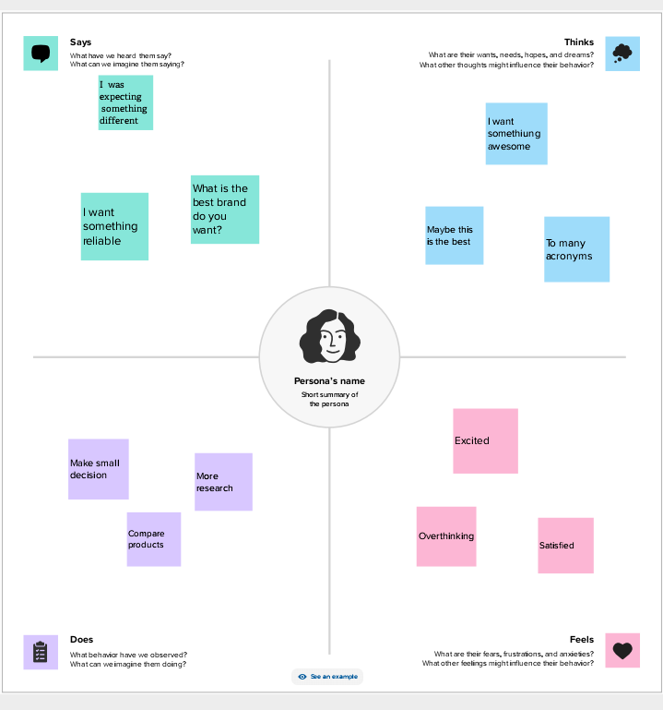

2.2. IDEATION & BRAINSTROMING MAP

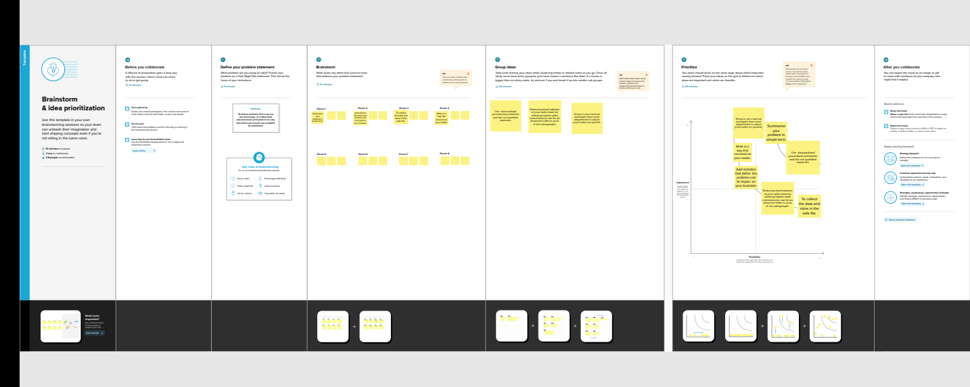

3.RESULT

3.1. DASHBOARD

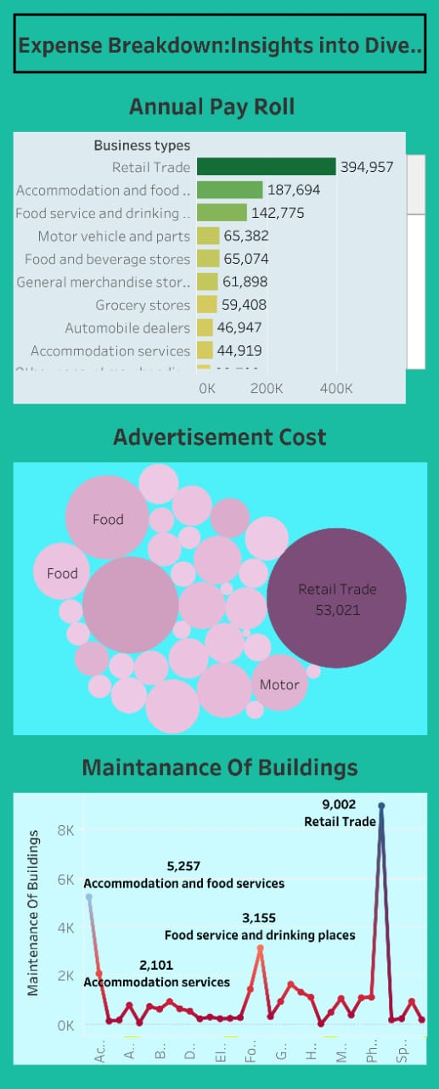

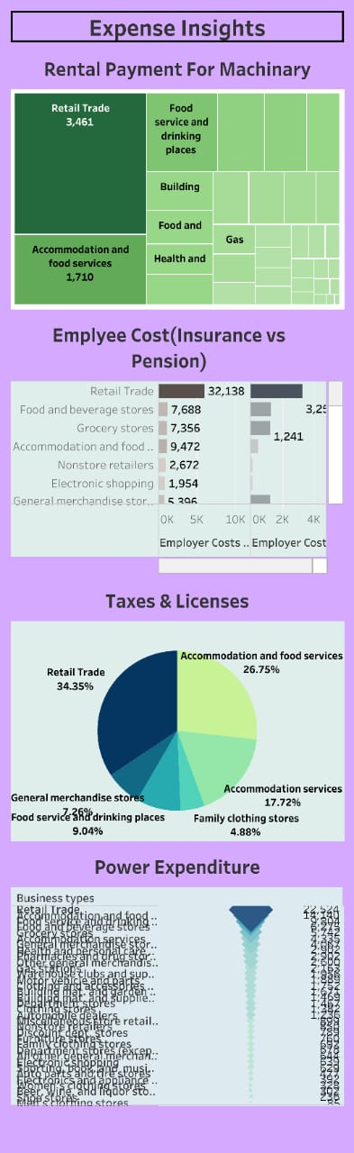

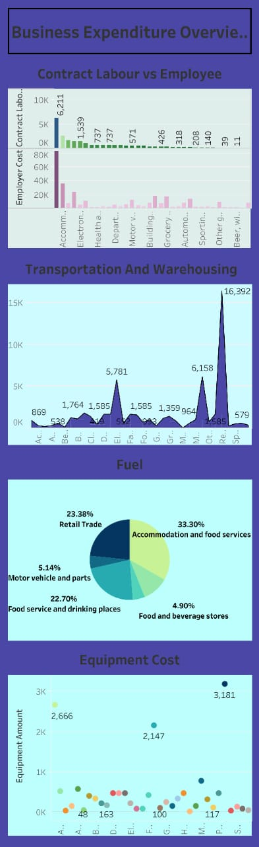

**3.2. STORY**

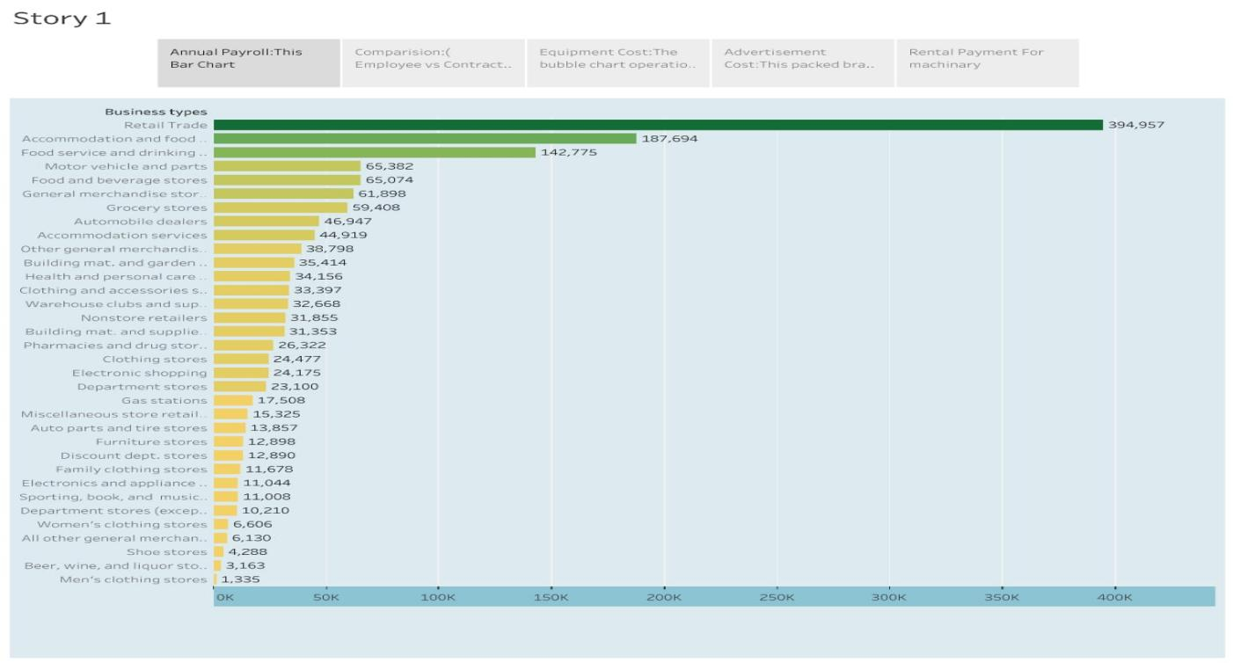

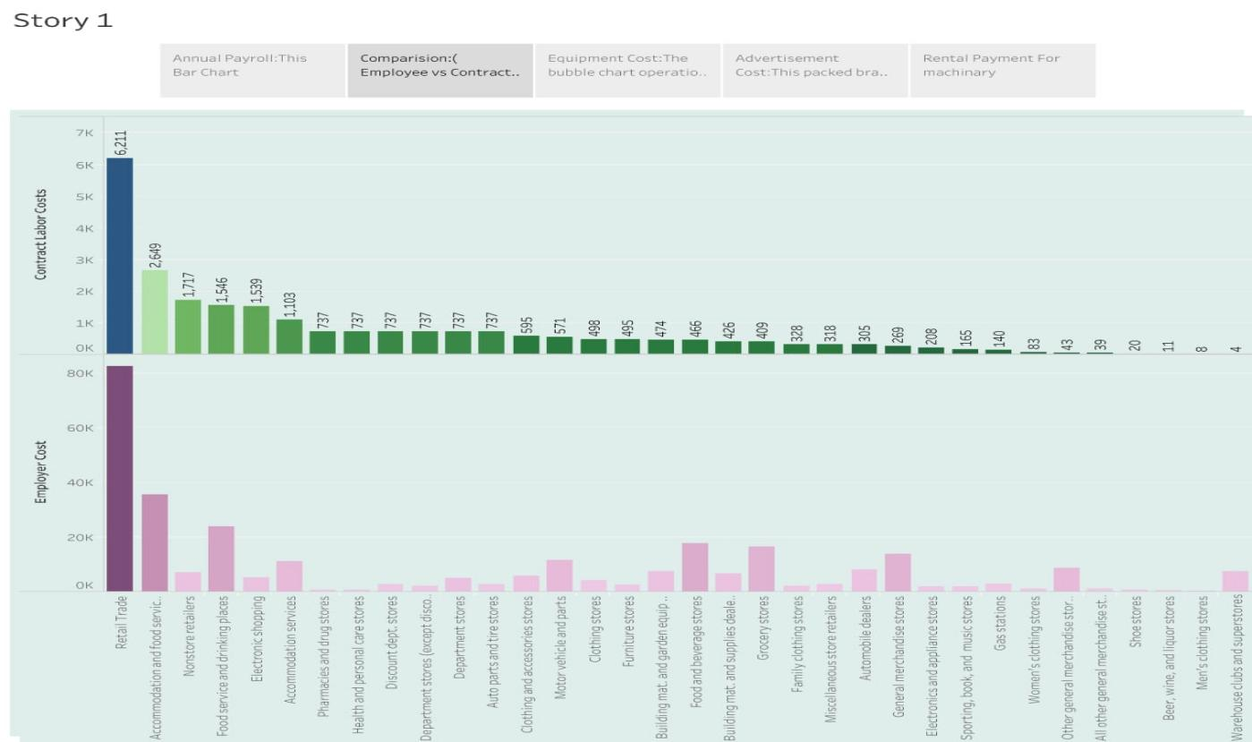

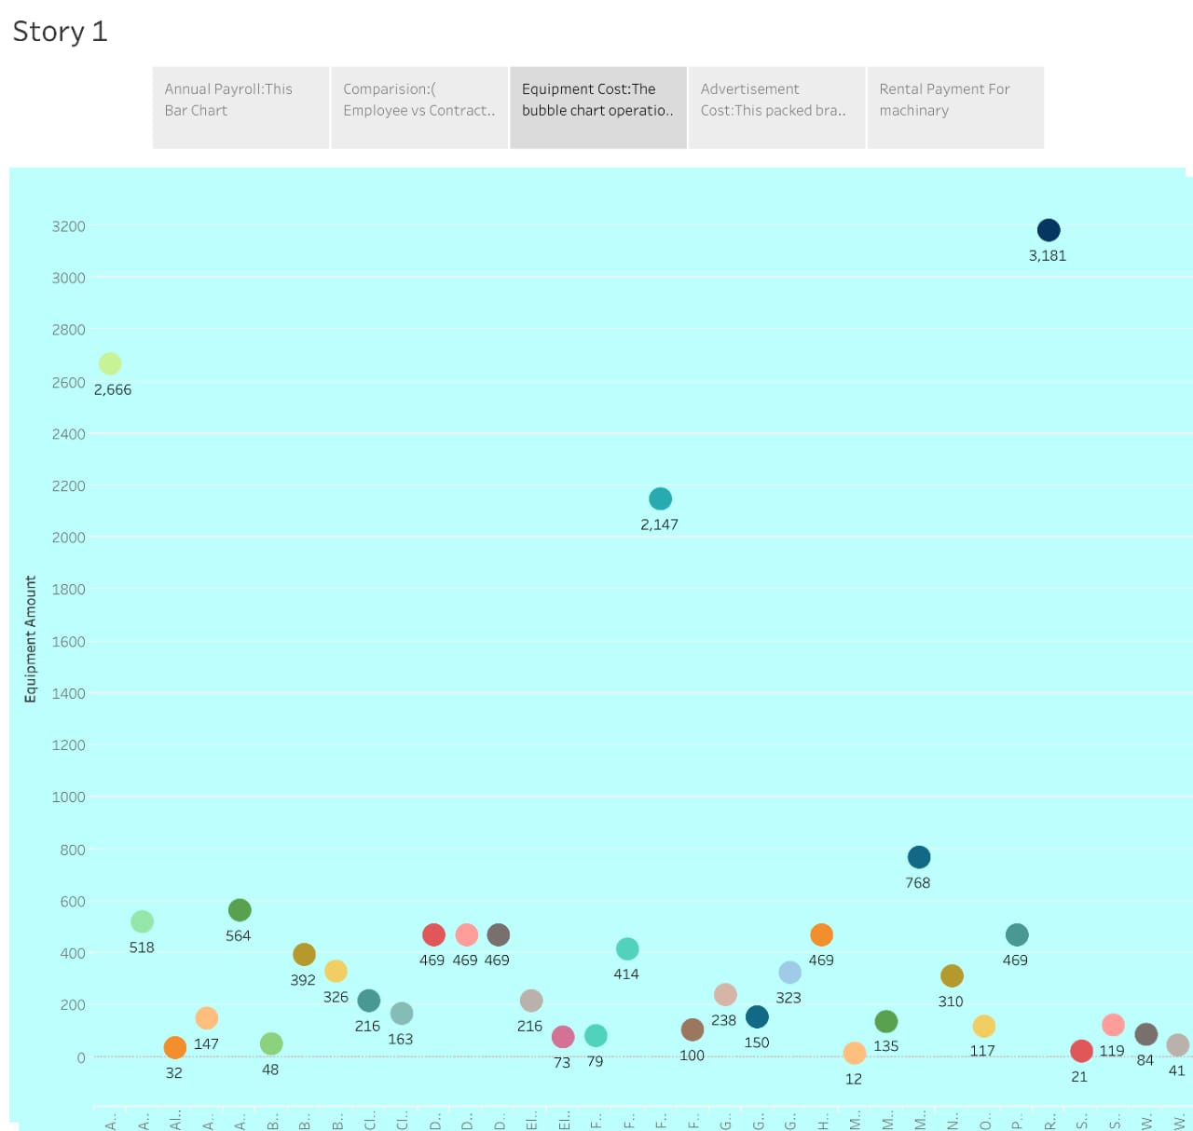

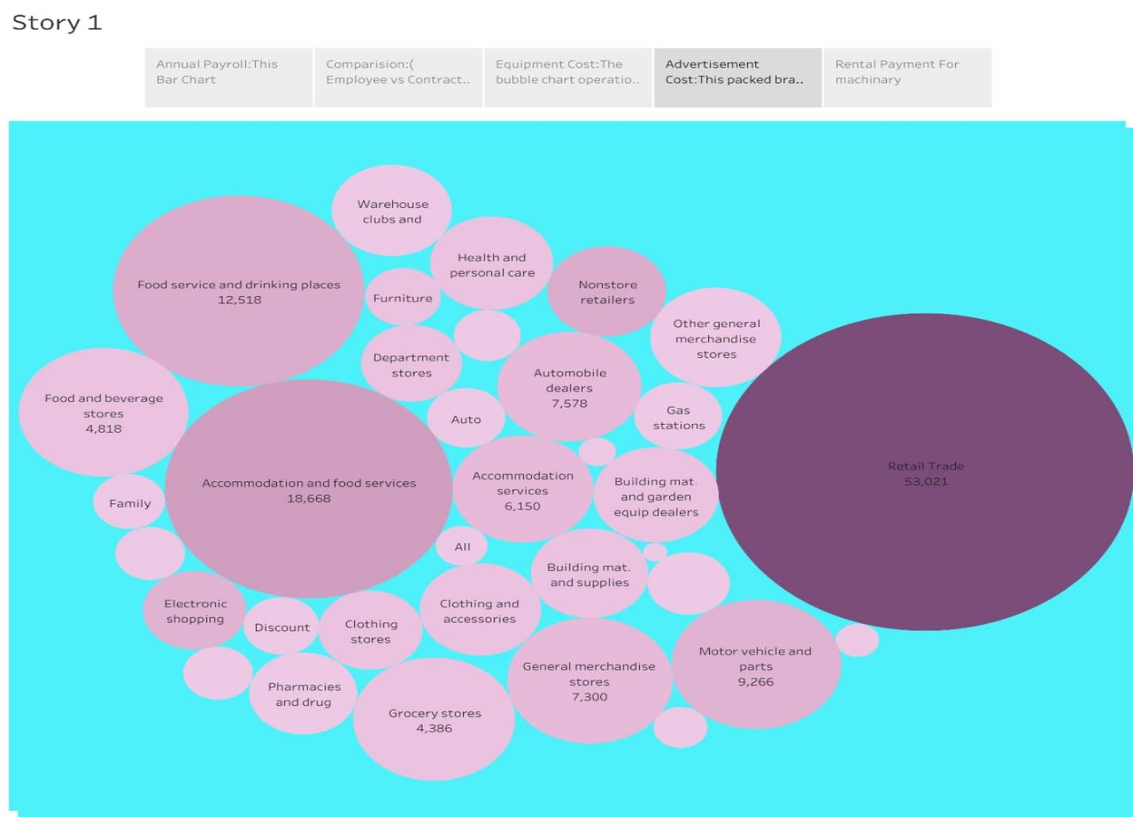

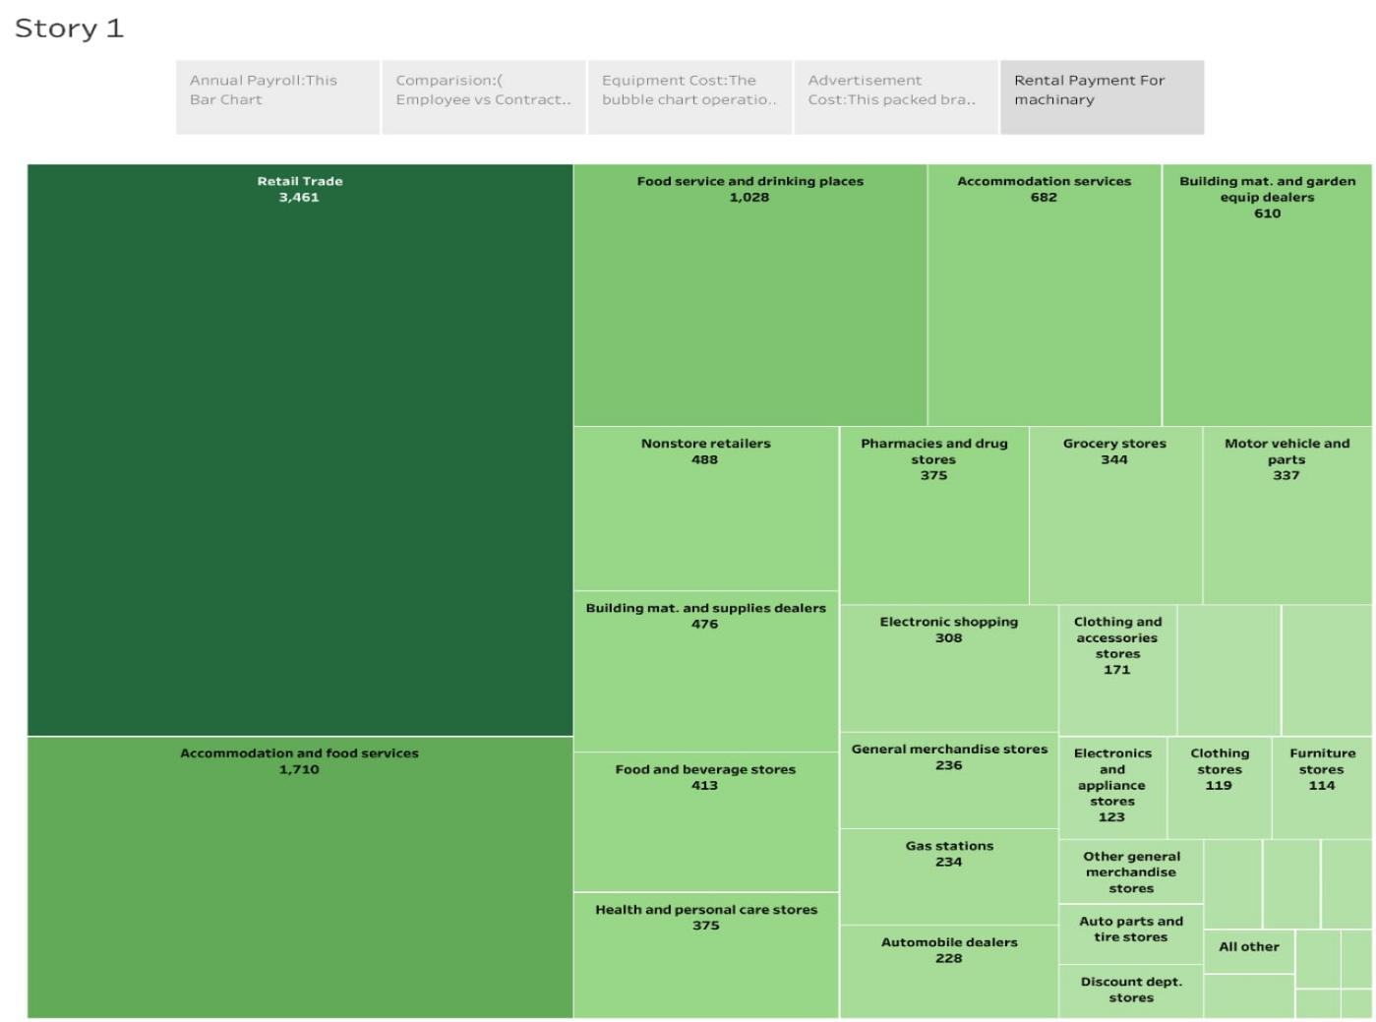

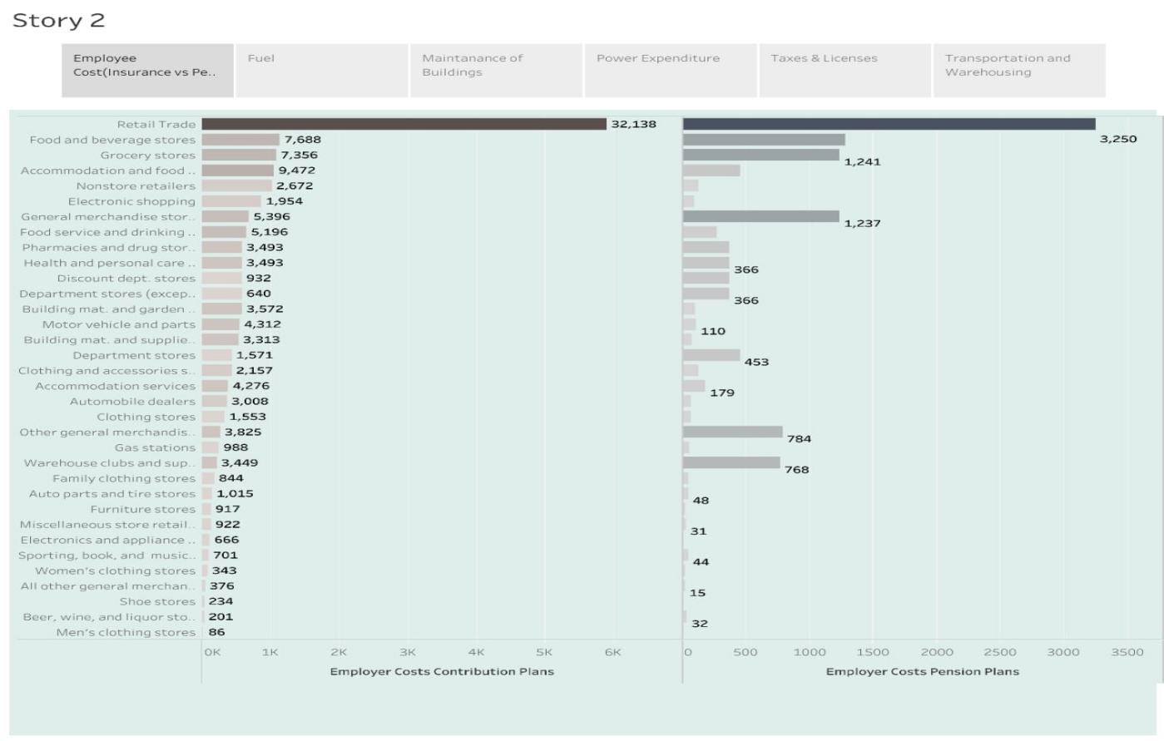

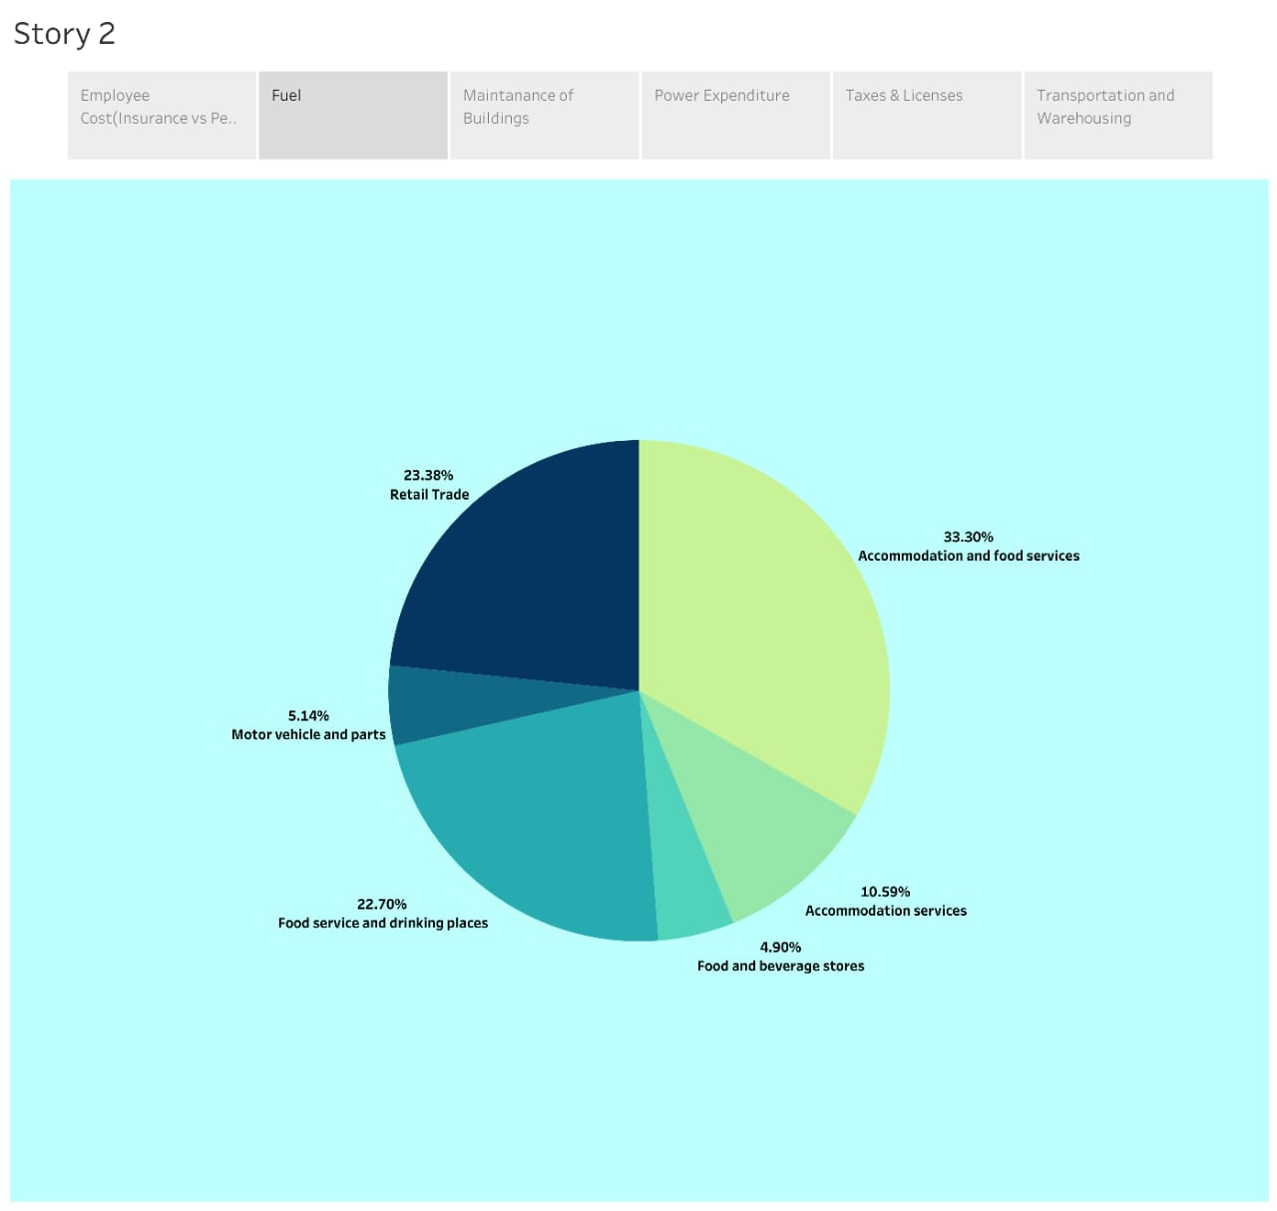

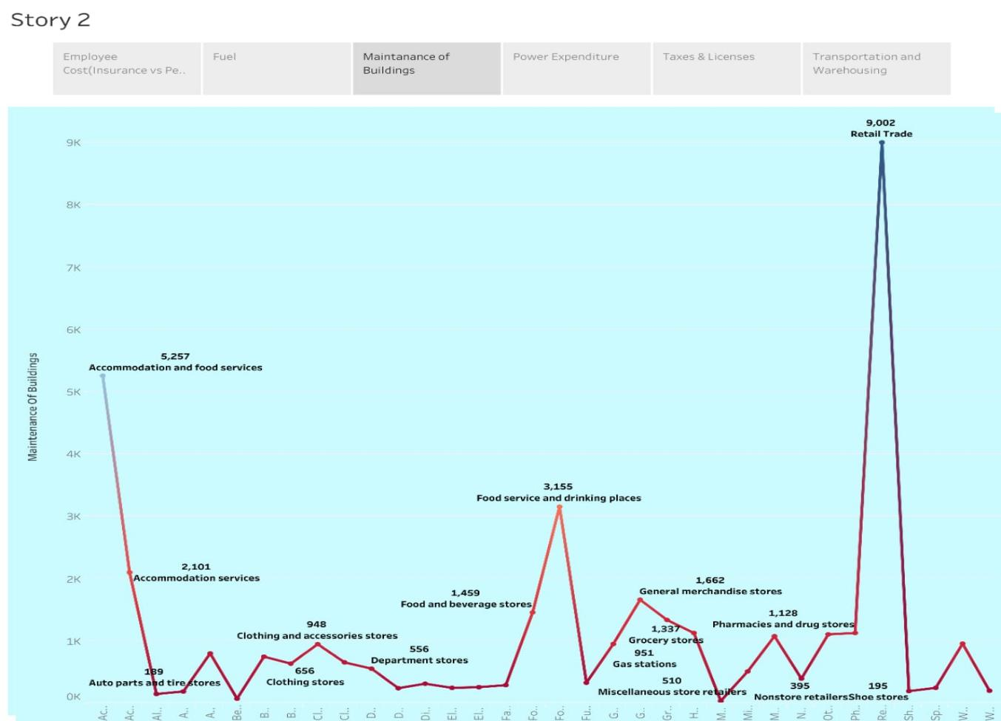

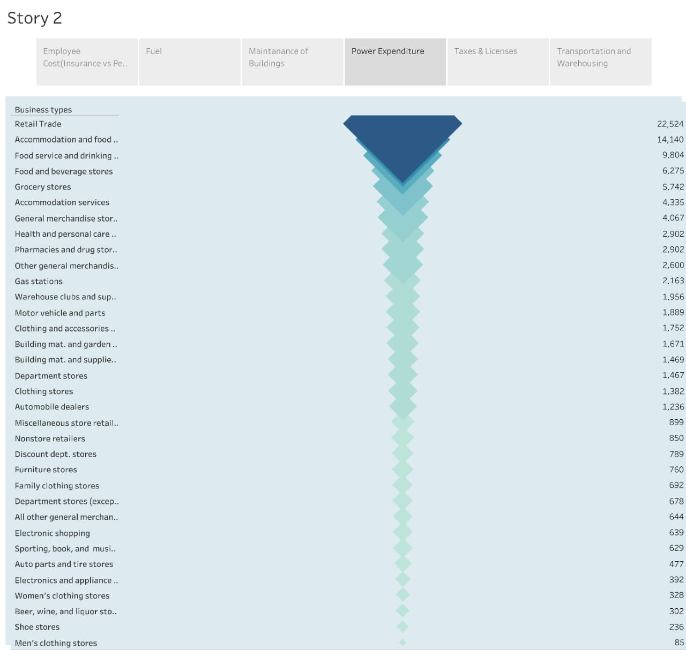

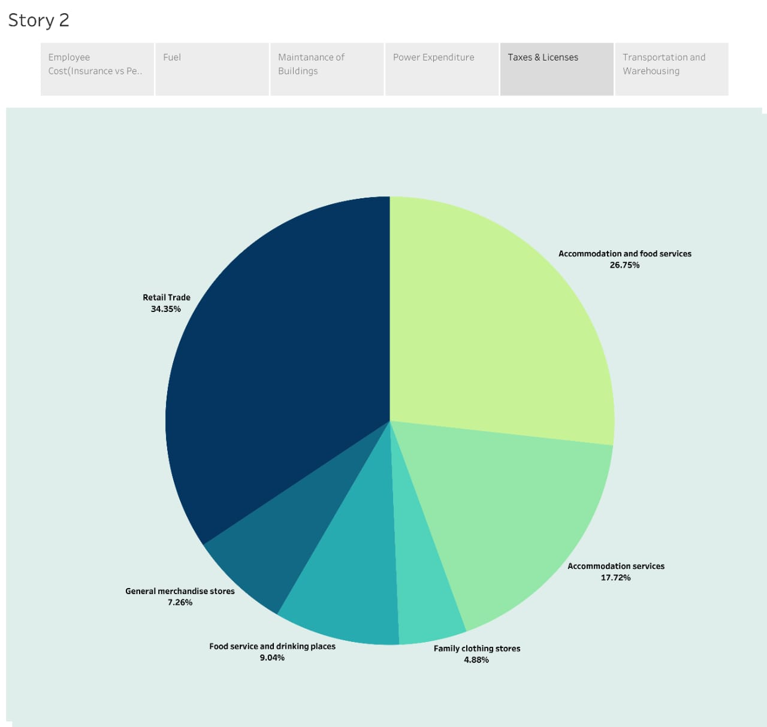

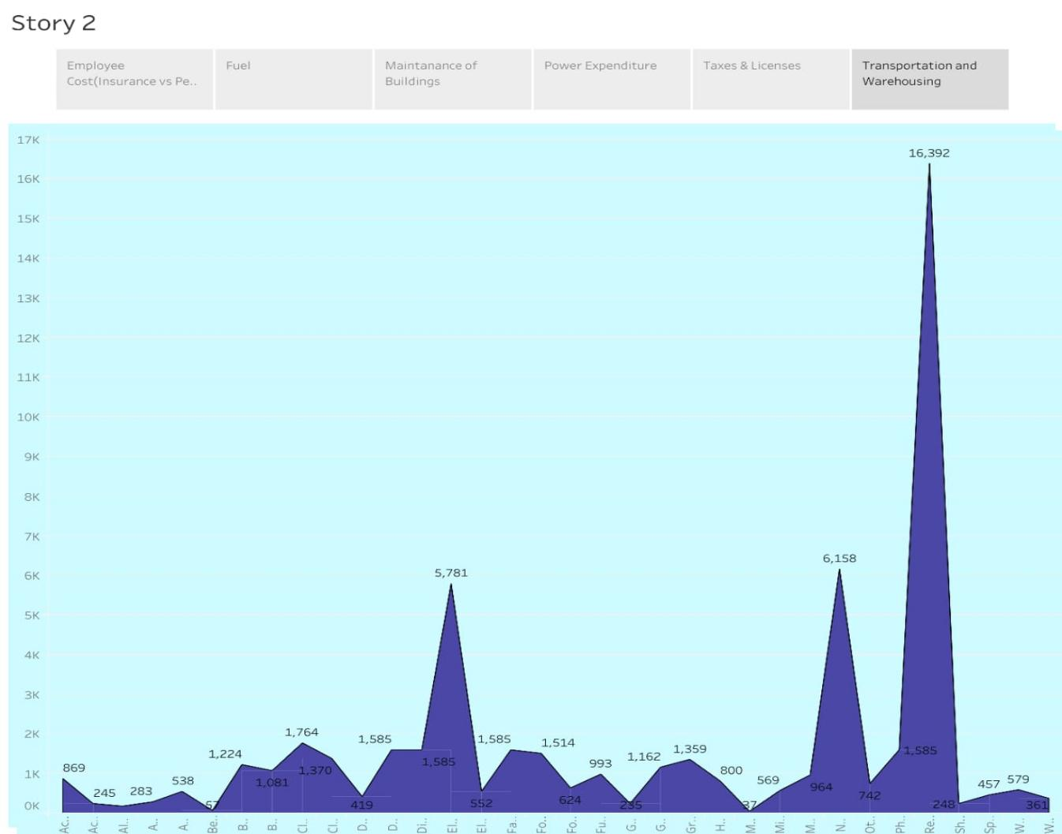

1. ADVANTAGES & DISADVANTAGES
   1. ADVANTAGES

Businesses of every size and type need accurate estimates from a project manager to help allocate and predict budgets, resources, and timelines. Without accurate cost estimates, businesses are left to rely on gut instincts and guesswork to allocate resources and manage projects.  If you can’t make an accurate cost estimate, you will fail to make a profit margin. Thus, knowing **why is it important to estimate** becomes essential for making a business successful.

### ****Building stronger client relations****

**Estimation benefits** you and your client by helping in better planning for all the construction costs of doing business. This also shows your clients that you take the time to understand how you can help them and how much money they’re investing in your business. Another benefit of estimating costs for a project is to help everyone involved be aware of what it costs.

****Checking profitability****

Estimating management costs is a critical part of operating a business. It helps you to know whether or not you will be able to profit off of a product. It allows you to know whether you need to raise the price of your product or if you can keep it at a steady cost.

### ****Prior Prediction****

A benefit of the cost estimating process is that you are prepared for any situation. If things go wrong, you’re prepared. If they go well, you’re prepared. Using a budget to determine how much to spend can help project managers determine what they can spend on different materials or construction processes. Knowing what you can spend can help you make right decisions for the entire team.

4.2.DISADVANTAGES

* **A shortage of cash.**You may need to borrow money to buy new premises or equipment to expand.
* **Increased capital requirements.**A larger business requires a larger workforce, more facilities or equipment, and often more investment.
* **Loss of control**. Larger businesses mean delegating more management duties or dividing workloads between different locations. This potentially can lead to compromised quality and lower staff morale, resulting in higher staff turnover, which in turn can damage your customer relationships.
* **Compromised productivity and quality**due to lack of resources. Management, staff and even your machines may not be able to keep up with the excess workload.
* One of the biggest mistakesis to **expand too quickly**. This can put your business at risk because growth can create excessive pressure on every aspect of the business from supplier to staff to all-important cash flow, all of which can push your business into a downward spiral.

5.APPLICATION

Also referred to as deductions, business expenses are the costs of operating a business. They're recorded on the income statement. These expenses will be subtracted from business revenue to show a company's net profit or loss and taxable income.

1.DASHBOARD

You can categorize [expense receipts](https://happay.com/blog/expense-receipt/) under each report on a single screen as you reconcile those numbers.

To help establish better expense budgets, you may choose to access real-time data on expenses constantly on your screen

You may customize a set of reports detailing a particular department’s expenses or deep dive into specific spending in a particular project.

2.MOBILE APP

Look for automated [expense reporting software](https://happay.com/blog/best-expense-reporting-software/) that offers intelligent and intuitive mobile apps. They can automate the capturing process and dramatically speed up the review, submission, and [approval process](https://happay.com/blog/expense-approval-process/).

1. FEATURES

* SmartScan feature
* Customized business expense management software
* Integrates across all Enterprise Resource Planning (ERPs)
* The convenience of delegated access

6.CONCLUSION

Businesses of every size and type need accurate estimates from their project managers to help allocate and develop budgets, resources, and different project duration. However, without an accurate estimating process, businesses are left to rely on gut instincts and guesswork to allocate resources and manage projects.

When it comes to accurate estimation units for your business, there is no better way to go about it than taking the time to do it right. By ensuring you have a good grasp of the project, you will be able to provide your customers with the best service possible.

If you want to digitize your service business and its entire operations, then FieldCamp is the best option. From job

scheduling to dispatching, invoicing to receiving payments,

FieldCamp handles it all in just a few clicks. Not only is it

extremely convenient to use, but it also provides data reports for better revenue management. So, start a 7-day FREE trial and explore a range of benefits.

7.FUTURE SCOPE

As per AACE International, recommended practice 10S-90, “scope is the sum of all that is to be or has been invested in and delivered by the performance of an activity or project. In project planning, the scope is usually documented (i.e., the scope document), but it may be verbally or otherwise communicated and relied upon. It is generally limited to that which has been agreed to by the stakeholders in an activity or project”.

Scope definition is dividing all major project deliverables into smaller, more manageable components to:

* Improve the accuracy of cost, schedule, and resource estimates
* Define a baseline for performance measurement and control
* Facilitate clear responsibility assignments
* This is the starting point for defining all project requirements to meet overall project objectives.
* Project Charter and Stakeholders Register are the two documents for the project team to follow. This also helps the project team in defining actual project scope.

THANK YOU